Chapter 01
Investments: Background and Issues

- Equity is a lower priority claim and represents an ownership share in a corporation, whereas debt has a higher priority claim, but does not have an ownership interest. Debt also pays a specified cash flow over a specific period and the claim will eventually expire. Equity has an indefinite life.

- A derivative asset provides a payoff that depends on the values of a primary asset. The primary asset has a claim on the real assets of a firm, whereas a derivative asset does not.

- Asset allocation is the allocation of an investment portfolio across broad asset classes. Security selection is the choice of specific securities within each asset class.

- Agency problems are conflicts of interest between managers and stockholders. They are addressed through the corporate governance process via audits, compensation structures and board elections.

- Real assets are assets used to produce goods and services. Financial assets are claims on real assets or the income generated by them.

- Investment bankers are firms specializing in the sale of new securities to the public, typically by underwriting the issue. Commercial banking processes the financial transactions of businesses such as checks, wire transfers and savings account management.

  - The factory is a real asset that is created. The loan is a financial asset that is created by the transaction.

  - When the loan is repaid, the financial asset is destroyed but the real asset continues to exist.

  - The cash is a financial asset that is traded in exchange for a real asset, inventory.

  - No. The real estate in existence has not changed, merely the perception of its value.

  - Yes. The financial asset value of the claims on the real estate has changed, thus the balance sheet of individual investors has been reduced.

  - The difference between these two answers reflects the difference between real and financial asset values. Real assets still exist, yet the value of the claims on those assets or the cash flows they generate do change. Thus, the difference.

  - The bank loan is a financial liability for Lanni. Lanni's IOU is the bank's financial asset. The cash Lanni receives is a financial asset. The new financial asset created is Lanni's promissory note held by the bank.

  - The cash paid by Lanni is the transfer of a financial asset to the software developer. In return, Lanni gets a real asset, the completed software. No financial assets are created or destroyed. Cash is simply transferred from one firm to another.

  - Lanni sells the software, which is a real asset, to Microsoft. In exchange Lanni receives a financial asset, 1,500 shares of Microsoft stock. If Microsoft issues new shares in order to pay Lanni, this would constitute the creation of new financial asset.

  - In selling 1,500 shares of stock for $120,000, Lanni is exchanging one financial asset for another. In paying off the IOU with $50,000 Lanni is exchanging financial assets. The loan is "destroyed" in the transaction, since it is retired when paid.

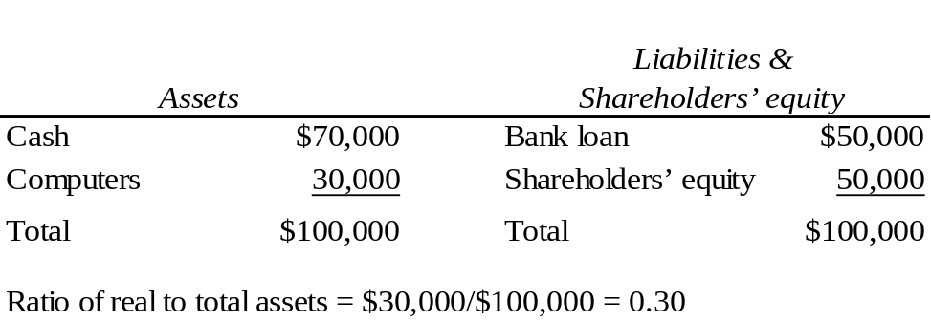

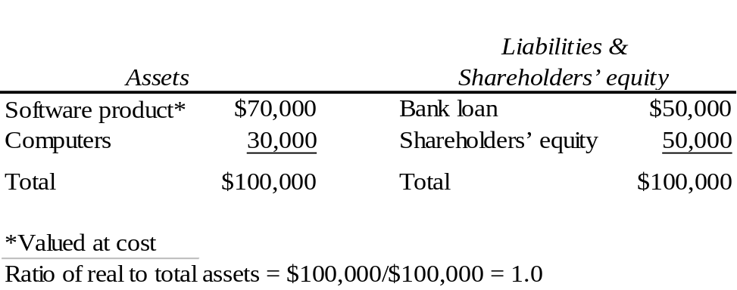

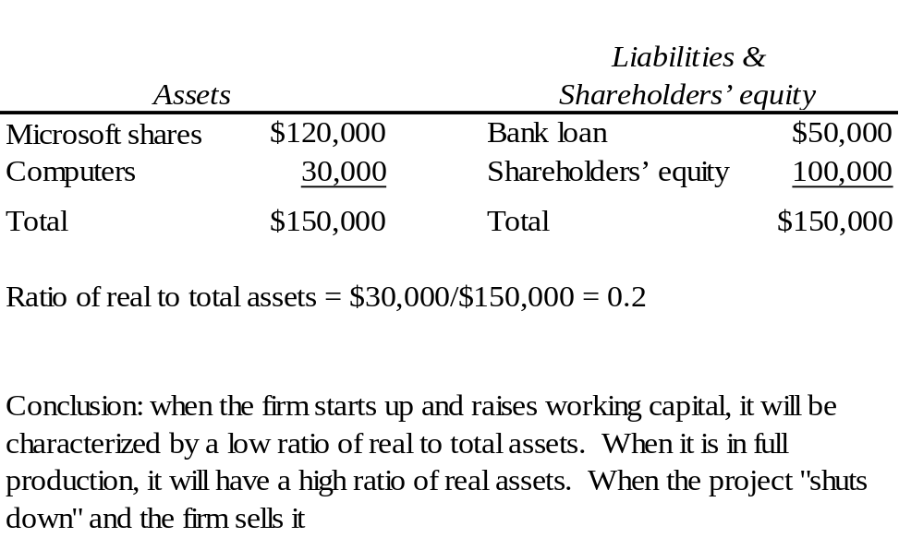

- Ultimately, real assets determine the material well being of an economy. Individuals can benefit when financial engineering creates new products which allow them to manage portfolios of financial assets more efficiently. Since bundling and unbundling creates financial products creates new securities with varying sensitivities to risk, it allows investors to hedge particular sources of risk more efficiently.

- For commercial banks, the ratio is: $121.2/$11,426.2 = 0.0106
For non-financial firms, the ratio is: $14,773/$28,507 = 0.5182
The difference should be expected since the business of financial institutions is to make loans that are financial assets.

- National wealth is a measurement of the real assets used to produce the GDP in the economy. Financial assets are claims on those assets held by individuals. These financial assets are important since they drive the efficient use of real assets and help us allocate resources, specifically in terms of risk return trade-offs.

  - A fixed salary means compensation is (at least in the short run) independent of the firm's success. This salary structure does not tie the manager’s immediate compensation to the success of the firm. The manager might, however, view this as the safest compensation structure with the most value.

  - A salary paid in the form of stock in the firm means the manager earns the most when shareholder wealth is maximized. When the stock must be held for five years, the manager has less of an incentive to manipulate the stock price. This structure is most likely to align the interests of managers with the interests of the shareholders. If stock compensation is used too much, the manager might view it as overly risky since the manager’s career is already linked to the firm. This undiversified exposure would be exacerbated with a large stock position in the firm.

  - When executive salaries are linked to firm profits, the firm creates incentives for managers to contribute to the firm’s success. The success of the firm is linked to the compensation of the manager. This may lead to earnings manipulation, but that is what audits and external analysts will look out for.

- If an individual shareholder could monitor and improve managers’ performance, and thereby increase the value of the firm, the payoff would be small, since the ownership share in a large corporation would be very small. For example, if you own $10,000 of IBM stock and can increase the value of the firm by 5%, a very ambitious goal, you benefit by only: 0.05 x $10,000 = $500.

In contrast, a bank that has a multimillion-dollar loan outstanding to the firm has a big stake in making sure the firm can repay the loan. It is clearly worthwhile for the bank to spend considerable resources to monitor the firm.

- Since the trader benefited from profits but did not get penalized by losses, they were encouraged to take extraordinary risks. Since traders sell to other traders, there also existed a moral hazard since other traders might facilitate the misdeed. In the end, this represents an agency problem.

- Securitization requires access to a large number of potential investors. To attract these investors, the capital market needs:
- a safe system of business laws and low probability of confiscatory taxation/regulation;
- a well-developed investment banking industry;
- a well-developed system of brokerage and financial transactions, and;
- well-developed media, particularly financial reporting.

These characteristics are found in (indeed make for) a well-developed financial market.

- Securitization leads to disintermediation; that is, securitization provides a means for market participants to bypass intermediaries. For example, mortgage-backed securities channel funds to the housing market without requiring that banks or thrift institutions make loans from their own portfolios. As securitization progresses, financial intermediaries must increase other activities such as providing short-term liquidity to consumers and small business, and financial services.

- Mutual funds accept funds from small investors and invest, on behalf of these investors, in the national and international securities markets.

Pension funds accept funds and then invest, on behalf of current and future retirees, thereby channeling funds from one sector of the economy to another.

Venture capital firms pool the funds of private investors and invest in start-up firms.

Banks accept deposits from customers and loan those funds to businesses, or use the funds to buy securities of large corporations.

- Even if the firm does not need to issue stock in any particular year, the stock market is still important to the financial manager. The stock price provides important information about how the market values the firm's investment projects. For example, if the stock price rises considerably, managers might conclude that the market believes the firm's future prospects are bright. This might be a useful signal to the firm to proceed with an investment such as an expansion of the firm's business.

In addition, the fact that shares can be traded in the secondary market makes the shares more attractive to investors since investors know that, when they wish to, they will be able to sell their shares. This in turn makes investors more willing to buy shares in a primary offering, and thus improves the terms on which firms can raise money in the equity market.

- Treasury bills serve a purpose for investors who prefer a low-risk investment. The lower average rate of return compared to stocks is the price investors pay for predictability of investment performance and portfolio value.

- You should be skeptical. If the author actually knows how to achieve such returns, one must question why the author would then be so ready to sell the secret to others. Financial markets are very competitive; one of the implications of this fact is that riches do not come easily. High expected returns require bearing some risk, and obvious bargains are few and far between. Odds are that the only one getting rich from the book is its author.

